Systems Design

Zach Anderson, Brandon Koss, Sean Liu, Suliman Buzakouk

March 16th, 2020

Final Report

Pumped Hydro Storage

Our team “The Entire Systems Design Class” wanted to tackle a significant problem that the energy industry faces both in sustainable and non-sustainable energy production. Pumped hydro-storage (PHS) is a great solution for balancing out the peaks and valleys in power production throughout the day. This is especially a large problem if solar and wind energy production is your main source of energy, but also can reduce overall energy production of coal, natural gas, and nuclear energy. This gives cities the ability to store energy when demand is less than production, and then supplying this stored up energy during the peak times of the day. This would allow more sustainable energy production like solar and wind to take a bigger overall role as energy producers, because of PHS’s ability to balance out the how inconsistent solar and wind is as energy producers.

PHS is only a way to store energy, not produce it. It works by having two different bodies of water at different elevations. This can be done with naturally occurring reservoirs, manmade reservoirs, or a combination of both. The idea is to use cheap or excess energy to pump water from the lower body of water to the higher body of water using pumps. When power is needed during peak times of the day when energy costs more, the system releases water from the higher reservoir through turbines to generate electricity. This system is just manipulating gravitational potential energy using water as its medium. This can generally be done at around 70-80% maximum efficiency. Even with these losses, power plants can make more money running at a lower capacity overall and selling the cheap stored potential energy for more during peak times. Solar, wind and other renewables also benefit from this. PHS has a great ability to throttle or increase its power production at a moment's notice making it incredibly valuable. This allows for much less exergy overall to be destroyed. The ability to load follow as well as having multiple turbines for active redundancy makes this a reliable way to store and use this energy.

We will be measuring effectiveness by considering the lowering of overall energy production (%) and overall PHS system efficiency (%). Certain things will make PHS much more beneficial in terms of money spent to make the system. Being able to use natural water reservoirs will drastically lower cost. The only downside is finding two natural bodies of water that meet the requirements (elevation difference, size, location) is a challenge. This also brings along with safety and preservation concerns for the environment. Potentially the more “man-made” the system becomes, the less sense it makes in terms of dollars per kilowatt storage.

Designing a new system requires a lot of thought and planning, to ensure that the design team understands the boundaries of the system it is essential to include a system context diagram. Figure 1 below describes the system and its inputs and outputs.

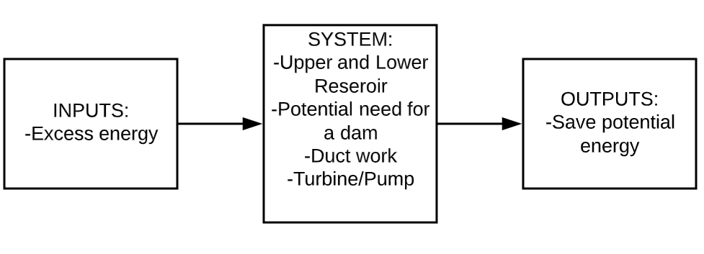

Figure 1: System Context Diagram

Pumped hydro storage has several key components that are necessary for the system to operate. To generate the potential energy required for the energy storage there needs to be two reservoirs at different heights. These reservoirs can be natural lakes at different elevations, or man-made tanks. The system may also require a dam to hold the water back so that the potential energy is not lost due to rivers allowing the pumped water to escape. Ductwork is a necessary component for PHS to work because it allows the fluid to be directed from the lower reservoir back into the higher reservoir in controlled environment. The pump/turbine is the heart of PHS, without this component you cannot use the excess energy created from outside sources to pump the water to the higher reservoir and then use the turbine to generate useful energy.

Not only do you need to define the boundaries of the system, it is crucial that the measures of effectiveness are explicit. For PHS one main method of effectiveness is the efficiency of the pump/turbine, for several PHS facilities the efficiency has been measured as high as 70-80%. For PHS to be practical and useful is needs to have the potential to reduce the energy production of several energy plants (coal, nuclear, natural gas). Figures 2 and 3 show how PHS can help reduce the necessary energy that is being produced. Because steady state energy production always needs be run higher than the demand of electricity there is a lot of wasted energy during the early hours of the day. However, PHS allows the overall energy production to be reduced because the energy that is not being used in the early hours of the day can be stored and used during the peak times of electricity used.



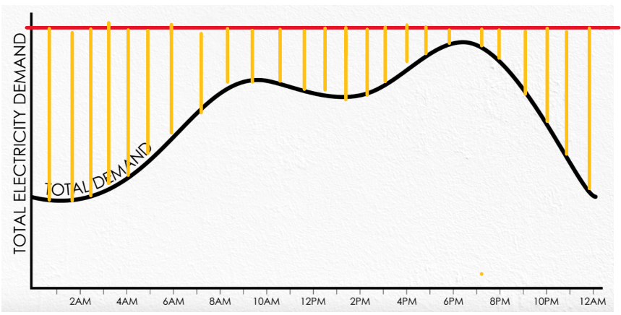

Figure 2: Required energy production without PHS



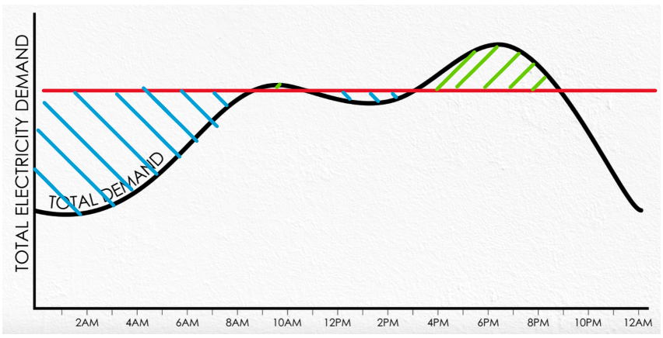

Figure 3: Required energy production using PHS

When creating any system that needs to be integrated into a society, it is important to evaluate any stakeholders that will be involved. Table 1 below summarizes some of the main stakeholders that we believe will be involved during the life-cycle of a PHS system.

Table 1: Summary of Stakeholders

|  |  |  |
| --- | --- | --- |
| **Stakeholder** | **Stake** | **Lifecycle phase** |
| Government | expenses | Conception, installations, operations and maintenance retirement and disposal |
| Public | Benefit from energy balancing, and stability during peak time | Operations |
| Engineers | Involved in designing the project | Design development, Fabrication, testing |
| Construction workers | Building and maintaining the project | Fabrication, installation, maintenance |
| Material suppliers | More materials being used for this project | Fabrication |

We can now break down the system into six separate categories: development, construction, Integration/testing/deployment, Operations, Maintenance, and Disposal. This allows us to take a huge system and break it down into manageable chunks that can be evaluated and designed. Let's start with the development phase. During the development process we need to perform small scale tests to ensure our idea will work the way we intend for it. Decide the best way to design a pump turbine system. We will also need to decide if we will be using two natural reservoirs or if we will be creating man-made reservoirs. Generally, when deploying a PHS system it is best to use two natural reservoirs because in order to store enough energy to be useful you need to pump thousands of gallons of water. Building reservoirs will simply be much too expensive and time consuming to be practical. After a build site has been chosen there needs to be some analysis to see if a dam is required. After the plans have been developed it is time to begin the construction phase.

During the construction phase we will follow the plans formed during the development phase to build our PHS system. We will start by retaining the water so that we aren’t losing any of the potential energy that we have created. Next, we will need to create a duct work system that transports the water from the lower reservoir into the higher reservoir. Also included will be a control room that will house the pump and turbine system. When we need to store the energy, the pump will run and when we need to use the energy the turbine will run. We also need to have a terminal where the power companies can tap into the stored energy after it has been converted from potential energy into electrical energy. After the system has been constructed, we will need to test its operations.

After the construction has been complete, we can perform large scale test similar to the small-scale ones we did during the development phase. We will want to test each component individually and then as a whole. Does the pump turn on and pump the water up the ducting? Does the ducting leak? Can we generate power using the turbine? Is the power in a useful form for the power companies to use and sell? These are all things that need to be tested thoroughly before we can implement the system to its full capacity. After the testing has been complete, we will begin the integration process. There will need to be a network of power lines leaving the PHS facilities that connect with the power distributor companies. During operations the PHS facilities will have to work closely with the power distributing companies to ensure that we are using the excess energy to store the energy and then return the stored energy during peak consumption times.

The PHS facilities will need to be routinely maintained to ensure that there are not any compromises to its strength. This could potentially be a big liability if the system ruptured causing thousands of gallons of water free all at once. It is also important to make sure that the pump and turbine are running at maximum efficiency so that there isn’t unnecessary loss of exergy. During the disposal cycle of a PHS facility it is important that we recycle all the controls and pump/turbine system. There are several rare earth metals that are involved in the production of these components. Unfortunately, there isn’t a lot that can be done for Recycling the infrastructure that was built to hold the water back. The dam built will need remain, however it will be opened so that the water can flow freely again. This prevents the water from building to dangerous levels and bursting through the dam.

After breaking our large system into smaller categories, it is manageable to investigate the different critical resources and their depletion time. Looking at each segment allows for some powerful calculations to take place that can paint a clear picture of how a PHS facility will be created.

After considering the critical resources needed to ensure that the hydro pumped storage would run smoothly and efficiently. The six phases are conception, design development, fabrication, integration, operation/maintenance, and retirement/disposal. Each of these phases will be crucial for the hydro pumped storage to be efficient and effective.  
 For the need for power storage (conception), currently we are producing more energy than is needed in the morning, this is because for most steady state plants (coal, nuclear) it is difficult to adjust the power output based on the power needed without needing to calibrate the entire system. Because of this the steady state plants need to consistently produce enough energy to provide energy during the power spike in the evenings. However, in the mornings when power isn't needed as much there is a lot of wasted energy. To help offset this waste the idea of rating a battery using potential energy was formed. This allowed the steady state plants to produce less energy over all (still too much in the morning but not enough for the evening). The PHS takes the extra energy created in the morning and stores it so that it can be used in the evening to cover the gap of missing power.   
 This project will take lots of patience and funds to manage. The biggest part of the design for PHS will be altering the location so that it meets our needs. If there are two natural lakes at different elevations, we will need to alter the land around the lakes to incorporate the duct work, the pump, and maybe a dam to keep the water back. The design for each location will be different because not all locations are in the same. However, the overall design should be similar for each PHS, there will be a pump, two reservoirs at different elevations, duct work, and a dam. Implementing them will be different for each site.  
 Building this hydro storage pump will also require a certain location that can support the pump to be most efficient. Concrete or any natural ingredient from the earth can be used, and money are the two biggest critical resources for developing a non-natural PHS facility. There will be an enormous amount of concrete that goes into making one of these man-made basins. An example of this is the Bath County pumped hydro storage facility. In 1985 it cost 1.6 billion dollars to make and was a massive project. “Pumped hydro boasts a very low price per megawatt hour, ranging from about $200/MWh to $260/MWh. Currently, battery costs range from $350/MWh to nearly $1000/MWh, with this cost reducing rapidly (costs reduced by about 25% during 2016). Ultimately, it’s difficult to predict how low the cost of batteries may go, but reports predict costs of lithium-ion batteries at somewhere around $120/MWh by 2025. For batteries, assuming an economic life of 40 years, the initial cost-plus replacements may mean whole-of-life costs fall in the range of $200/MWh to $330/MWh.”

For this to be implemented into effect we would need lots of metals like aluminum. To integrate our PHS into the energy grid depending on its location large transmission lines and other supporting electrical infrastructure will need to be made. Critical resources for these would be the metal used to make the transmission lines (Aluminum on the outside with steel reinforcement) and all the steel needed for the towers and subsequent electrical grid improvements. Dams would need to flow steady water strong enough to move the turbines to produce enough electricity. The way makes sure the water is enough is that we need two different reservoirs that are at different elevations. This is because reservoirs must generate power discharge as water flows down through a turbine. This leads to power being drawn out as it pumps water to the upper reservoir.

Getting rid of something well-made and efficient would be hard to do. This part of the process becomes very tricky with the man-made concrete lake PHS and less with natural bodies of water. Once you make an enormous concrete lake, there isn’t an option to get rid of it. Disposal will only be a thing for the water turbines and everything that is not concrete. There may be a potential to repurpose the man-made lakes for other activities, but the options are very limited.

Depletion rate of the land of the pumped hydro storage is difficult to find. The hydro pump storage needs about 500 meters of horizontal space for the upper and about 200 meters of space for the lower reservoirs. On average it takes about 150000 km2 of land used a year and because we cannot make more land, we can only use up what we have (134000000 km2). This will approximately take around 890 years to use up.

A PHS system typically pumps water to an upper reservoir when loads and electricity prices are low, and subsequently releases the water back to a lower reservoir through a turbine when loads are high, and electricity is more expensive. Moreover, PSH is a flexible resource that contributes to balance supply and demand in the power grid. Figure 4 and figure 5 down below give you an idea of how the system work as well as show the relation between each element in the system along with their boundaries.

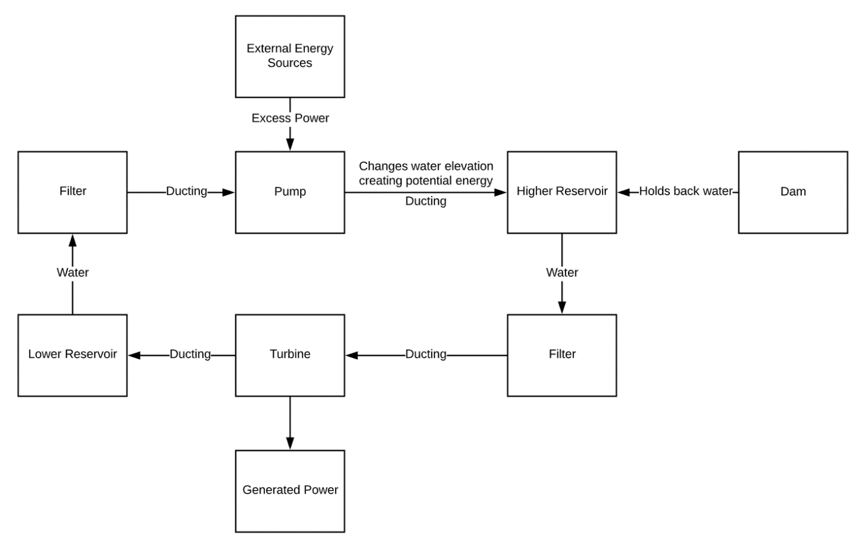

Figure 4: The block diagram of PHS system.

|  |  |  |  |  |  |  |  |  |
| --- | --- | --- | --- | --- | --- | --- | --- | --- |
| External Power Source |  |  |  | Provides power |  |  |  |  |
|  | Lower Reservoir | Ducting |  |  |  |  |  |  |
|  |  | Water | Ducting |  |  |  |  |  |
|  |  |  | Filter | Filtered water |  |  |  |  |
|  |  |  |  | Pump | Supplies water |  |  |  |
|  |  | Ducting |  |  | Higher Reservoir |  | Supplies water |  |
|  |  |  |  |  | Holds Water | Dam |  |  |
|  |  |  |  |  |  |  | Turbine | Supplies power |
|  |  |  |  |  |  |  |  | Power Grid |

Figure 5: The N2 chart of PHS system.

In general, PHS units are characterized by several key performances, including their head, flow rate, waterway length, reservoir size, and the motor’s efficiency. The head is the vertical distance between the upper and lower reservoirs, typically between 100 and 2500 ft. The combination of the head and the flow rate of the PHS system determines its capacity. The length of the waterway connecting the upper and lower reservoirs is a major contributing factor to the total cost of the project. PSH projects tend to have relatively short waterways to increase performance and efficiency. The Reservoir size is dependent on various other characteristics of the project, including land acquisition cost as well as physical and geological conditions, and the needs of the electric power system. Design and selection of the pump/turbine take into account a multitude of factors, such as setting in relation to upper and lower reservoir levels, specific speed, synchronous speed, and other factors. The selection of synchronous speed is an important factor in overall performance, operating cost.

When water is released from the upper reservoir, it carries energy along with it. Let’s assume that a cubic meter of water has a mass of 1000 kg and our dam is 100 meters high. The energy in the cubic water is PE = (m*g*h) therefore PE = (1000 kg) * (10 m/s²) * (100 m) = 10^6 J, or one megajoule. If this 100 m high dam only has one cubic meter per second flowing through, it would produce 1 MJ/sec, or 1 MW. Typically, flow rates are measured in the 1000 m³/s range, so that our 100 m dam would produce 1 GW at this scale. Our system is 70% efficient, so that would make it 700 MW.

The system’s topological and geological characteristics control the configuration of the elements. Down below are our topological boundaries of our system. We try to protect the pump and the turbine from overheating and vibration to keep them as efficient as possible. We also have to protect our electrical components from being exposed to water. Moreover, we have to protect the reservoirs from contaminations and dirt as they might clog the filters and reduce our flow rate and that leads to a less efficient system.

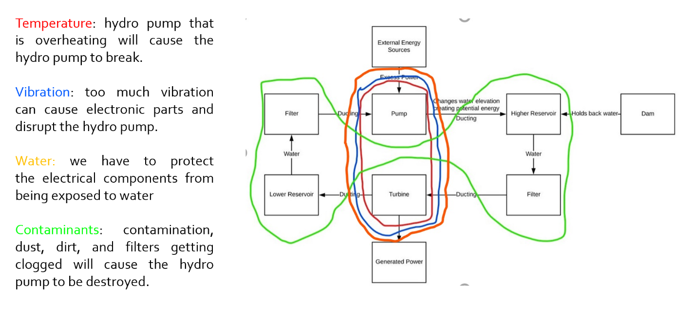Figure 6: The topological boundaries of the system.

In the development, operations and maintenance of the pumped hydro storage system there are several safety and reliability issues. While these are factoring that shouldn’t be taken lightly, the benefits of the system make it worthwhile. The safety will vary depending on how much of the natural region we are able to take advantage of during the development phase. It may be necessary to have to make one or both lakes in the system. If making man-made lakes, it will require a massive land moving operation. This will greatly reduce safety from all the heavy machinery operating and the large amount of people required to finish the project. There will be safety concerns when pouring the concrete, connecting to the electrical grid, and almost all forms of the building process. Reliability will also be a concern in the development phase. Depending on building/ structural techniques used, it could greatly alter how reliable the system is as a whole. If a cheaper method is used for construction this will affect how long, it will last.

During operations safety will be a large concern. At the pumped hydro storage itself as well as the entire electrical pathway to the customer. Having millions of cubic feet of water at a high elevation being held back by potentially a man-made wall, could end up catastrophic. Structure safety checks would need to be plentiful. During normal operation, massive amounts of electricity will be made and will cause hazards. This will require an intense level of precautions to be taken. In general, near the turbines will be a hazardous area that needs to have ample levels of safety. Reliability is the main concern with this system. The point of it, is to have energy available during the peak hours so constant rate energy production plants (nuclear, coal etc...) can be ran at a lower amount. The water basin will need to be able to contain water with no risk of breaking. The turbines will need to be extremely reliable to be able to run for extended periods at a time, with hopefully no problems. On top of this the electrical in the pumped hydro storage must be up to the standards. In our system if it was to fail during operation this would lead to power outages and potentially dangerous situations.

In order to safely perform maintenance for our PHS system there needs to be an all kill power switch that physically disconnects the turbine from any power source. This allows the engineers to safely inspect the turbine without fear of the turbine turning on and causing severe injury. It is also vital to make sure that the access route for inspecting structural maintenance are clear of obstacles (tripping hazards, pipes and wires hanging from the ceiling etc.) and that is well lit with clear signs to the exit in the case of an emergency. It is also important that the reliability of the equipment and infrastructure is high. Needing to repair or rebuild any infrastructure or pumps can be very costly and if repairs need to be constantly made this could easily shut down the PHS plant.

In order to address cognitive considerations, the devices incorporated in our system will have instruction manuals posted on the device that highlight the major functions of the device. Some examples of this include the turbine generators and how they operate, the system for connecting to the power grid and how to kill the power in case of an emergency. Also included will be instructions on how to handle different warning situations. Some other interfaces included may be ones that report power generated and how much was stored as well as the efficiency of the pump.

Some ergonomic considerations include ease of access for different components of our system. Designing the turbine so that the parts that have the highest probability of failing will be the easiest to access. Build access routes so that inspecting the building and infrastructure is easy to accomplish.

PHS is a great option in certain circumstances. If the system can take advantage of natural occurring water reservoirs with minimal construction PHS has a very low dollar per kilowatt stored value. The system allows inconsistent forms of energy production like solar and wind to become sources of energy society can rely on. As of right now “Solar and wind energy provide almost 10% of total generation in the US in 2019”(renewableenergyworld). We hope that PHS and other complimenting systems can bring that to a much higher percent. The downside is that the price of constructing man made reservoirs gets out of control fast, making it less worthwhile. The energy density of PHS is poor. To put this in relatable terms, 220lbs of water raised 33 feet matches the same amount of energy stored in an AA battery. This starts to paint the picture of how massive a PHS must be to be effective for a large population. Even with this said, we believe PHS is an extremely valuable addition to the power grid that will be needed on the route of energy production we are taking as a society.

References

Asher, C. (2018, March 31). How much land on Earth is inhabited? Retrieved from <http://www.curiousmeerkat.co.uk/questions/much-land-earth-inhabited/>

Bath County Pumped Storage Station. (2019, November 26). Retrieved from <https://en.wikipedia.org/wiki/Bath_County_Pumped_Storage_Station>

Batteries vs pumped storage hydropower – a place for both? (2017, June 21). Retrieved from <https://reneweconomy.com.au/batteries-vs-pumped-storage-hydropower-place-87554/>

Pumped-storage hydroelectricity. (2020, March 14). Retrieved from https://en.wikipedia.org/wiki/Pumped-storage_hydroelectricity

Pumped-Storage Hydropower. (n.d.). Retrieved from <https://www.energy.gov/eere/water/pumped-storage-hydropower>

Solar and Wind Energy (2019, October, 19) Retrieved from

https://www.renewableenergyworld.com/2019/10/28/solar-and-wind-energy-provide-almost-10-percent-of-total-generation-in-the-us-in-2019/#gref

Appendix

|  |  |  |
| --- | --- | --- |
| Standard Category | Standard Use | Standard |
| OSHA Concrete Standards  <https://www.osha.gov/SLTC/concreteproducts/standards.html#const_standards> | [Subpart D](https://www.osha.gov/laws-regs/regulations/standardnumber/1926#1926_Subpart_D) – Occupational Health and Environmental Control | [1926.55](https://www.osha.gov/laws-regs/regulations/standardnumber/1926/1926.55), Gases, vapors, fumes, dusts, and mists |
| [Subpart E](https://www.osha.gov/laws-regs/regulations/standardnumber/1926#1926_Subpart_E) – Personal Protective Equipment | [1926.95](https://www.osha.gov/laws-regs/interlinking/standards/1926.95), Criteria for personal protective equipment |
| [Subpart I](https://www.osha.gov/laws-regs/regulations/standardnumber/1926#1926_Subpart_I) – Tools - Hand and Power | [1926.100](https://www.osha.gov/laws-regs/regulations/standardnumber/1926/1926.100), Head protection |
| [Subpart K](https://www.osha.gov/laws-regs/regulations/standardnumber/1926#1926_Subpart_K) – Electrical | [1926.404](https://www.osha.gov/laws-regs/regulations/standardnumber/1926/1926.404), Electrical, wiring design and protection |
| [Subpart Q](https://www.osha.gov/laws-regs/regulations/standardnumber/1926#1926_Subpart_Q) – Concrete and Masonry Construction | [1926.700](https://www.osha.gov/laws-regs/interlinking/standards/1926.700), Scope, application, and definitions applicable to this subpart |
| [1926.701](https://www.osha.gov/laws-regs/interlinking/standards/1926.701), General requirements |
| [1926.702](https://www.osha.gov/laws-regs/interlinking/standards/1926.702), Requirements for equipment and tools |
| [1926.703](https://www.osha.gov/laws-regs/interlinking/standards/1926.703), Requirements for cast-in-place concrete |
| [1926.704](https://www.osha.gov/laws-regs/interlinking/standards/1926.704), Requirements for precast concrete |
| [1926.705](https://www.osha.gov/laws-regs/interlinking/standards/1926.705), Requirements for lift-slab operations |
| [Subpart G](https://www.osha.gov/laws-regs/regulations/standardnumber/1910#1910_Subpart_G) – Occupational Health and Environmental Control | [1910.94](https://www.osha.gov/laws-regs/regulations/standardnumber/1910/1910.94), Ventilation |
| [1910.95](https://www.osha.gov/laws-regs/regulations/standardnumber/1910/1910.95), Occupational noise exposure |
| [Subpart I](https://www.osha.gov/laws-regs/regulations/standardnumber/1910#1910_Subpart_I) – Personal Protective Equipment | [1910.132](https://www.osha.gov/laws-regs/regulations/standardnumber/1910/1910.132), General requirements |
| [Subpart Z](https://www.osha.gov/laws-regs/regulations/standardnumber/1910#1910_Subpart_Z) – Toxic and Hazardous Substances | [1910.1000](https://www.osha.gov/laws-regs/interlinking/standards/1910/1910.1000), Air contaminants |
| Water cleaning laws (United States Environmental Protection Agency EPA) | These standards ensure that we aren’t hurting the environment, damaging someone else's use of the water, polluting the water and various other things that need to be considered. | <https://www.epa.gov/wqs-tech/water-quality-standards-handbook>  The link takes you to a handbook that has countless standards on water quality. Some include being aware of downstream uses, (40 CFR 131.10(b)), attainability uses (40 CFR 131.10(d)) and many more. |
| OSHA Occupational Noise Laws  <https://www.osha.gov/laws-regs/regulations/standardnumber/1910/1910.95> | Occupational noise exposure. | 1910.95 |
| Building laws | Required to make sure that any construction or building is up to code and safe | <https://www.astm.org/Standards/building-standards.html> |
| Digging laws  <https://www.osha.gov/SLTC/trenchingexcavation/index.html> | Ensure that workers are being safe as they dig necessary trenches for duct work and other needs | [29 CFR 1926.650](https://www.osha.gov/laws-regs/regulations/standardnumber/1926/1926.650), [29 CFR 1926.651](https://www.osha.gov/laws-regs/regulations/standardnumber/1926/1926.651), and [29 CFR 1926.652](https://www.osha.gov/laws-regs/regulations/standardnumber/1926/1926.652) |

|  |  |
| --- | --- |
| **Team Member** | **Percent contribution to this assignment** |
| Sean Liu | 25% |
| Brandon Koss | 25% |
| Suliman Buzakouk | 25% |
| Zach Anderson | 25% |